DATABASE MANAGEMENT SYSTEMS

MINI PROJECT REPORT



**DEPT. Of Computer Science Engineering**

**SRM IST, Kattankulathur – 603 203**

**18CSC303J – DATABASE MANAGEMENT SYSTEMS**

**DBMS MINI PROJECT**

**SEMESTER VI**

**SUBMITTED BY**

RAJAT KUMAR (RA1911003010652)

AMAN KALLA (RA1911003010640)

**SECTION**

B2



**SRM INSTITUTE OF SCIENCE AND TECHNOLOGY**

(Under Section 3 of UGC Act, 1956)

**BONAFIDE CERTIFICATE**

**Certified to be the bonafide record of the work done by Rajat Kumar (RA1911003010652) and Aman Kalla (RA1911003010640), of VI Semester, Third Year B. Tech Degree course in SRM Institute of Science and Technology of *Computer Science & Engineering* Department in the *18CSC303J-Database Management Systems* during the academic year *2021-2022*.**

**SIGNATURE Dr.T Senthil Kumar Course Faculty Associate Professor** Department of computing technologies SRM Institute of Science and Technology Potheri, SRM Nagar, Kattankulathur, Tamil Nadu 603203

# ABSTRACT

Title – Wikipedia Lite Version

Wikipedia Lite Version is a Database Management Project consisting of front end which is an user interface and database in the backend part.

Main aim of the project Wikipedia Lite Version is to get some information according to corresponding input provided by the user.

MongoDB and Node.jsare used to connect back-end part with the user interface.

HTML, CSS and JavaScript are used for Front-end in the project.

**ACKNOWLEDGEMENT**

We express our heartfelt thanks to our honorable Vice Chancellor

**Dr. C. MUTHAMIZHCHELVAN**, for being the beacon in all our endeavors.

We would like to express my warmth of gratitude to our Registrar

**Dr. S. Ponnusamy**, for his encouragement.

We express our profound gratitude to our **Dean (College of**

**Engineering and Technology) Dr. T. V.Gopal**, for bringing out novelty in all executions.

We would like to express my heartfelt thanks to Chairperson, School of Computing **Dr. Revathi Venkataraman**, for imparting confidence to complete my course project.

We wish to express my sincere thanks to Course **Audit Professor**

**Dr. M.LAKSHMI, Professor and Head, Data Science and Business Systems and Course Coordinator Dr.Alice K, Associate Professor, Department of computing technologies for** their constant encouragement and support.

We are highly thankful to our my Course project Internal guide

**T Senthil Kumar, Associate Professor, Department of Computing Technologies**, for **his** assistance, timely suggestion and guidance throughout the duration of this course project.

We extend my gratitude to **Pushpalatha M, Head Of Department, Department of Computing Technologies** and my Departmental colleagues for their Support.

Finally, we thank our parents and friends near and dear ones who

directly and indirectly contributed to the successful completion of our project.

Above all, I thank the almighty for showering his blessings on me to complete my Course project.

**INTRODUCTION**

**AIM OF THE PROJECT:**

Aim of the project is to get some information according to corresponding input provided by user.

**PURPOSE OF THE PROJECT:**

The project ‘Wikipedia Lite Version’ is a Database project where we can store data. Data which is stored in the database can be acquired by giving proper input. This project works like a ‘Dictionary’ where limited data can be searched in limited database.

The working of this project as similar to search engines with requirements of database. Database is stored in the backend which is made using Node,js and MongoDB.

**GOALS:**

To get some information according to corresponding input .

**SCOPE OF THE PROJECT:**

Search Engines or dictionary are the things which provide useful knowledge or information according to user’s wish.

Inspired from things mentioned above, this project is made.

The project consists of front-end user interface from which we can type the data or information which we want to search. After the input is given, rest of the part is done by backend.

Software searches the information about the input in the database and present it on the user interface. By this, we will get our required output.

**OUTPUT:**

**UI PART:**

This is our Front page.

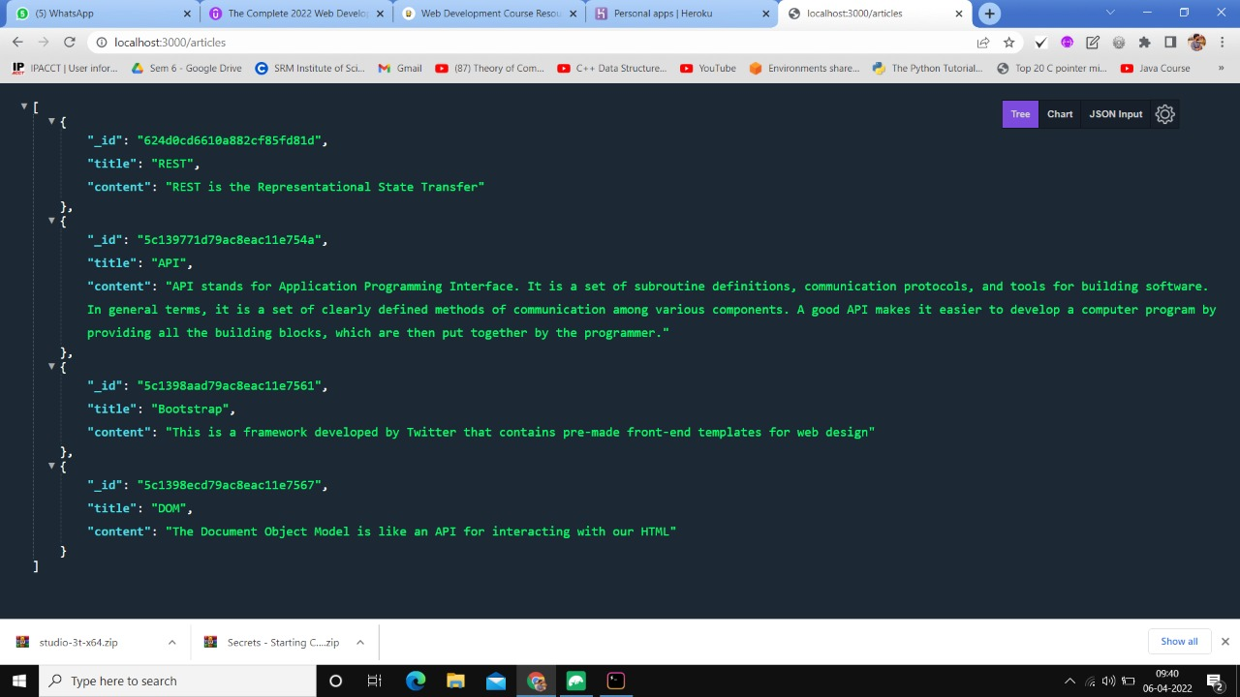

**DATABASE PART:**

This is out database part.

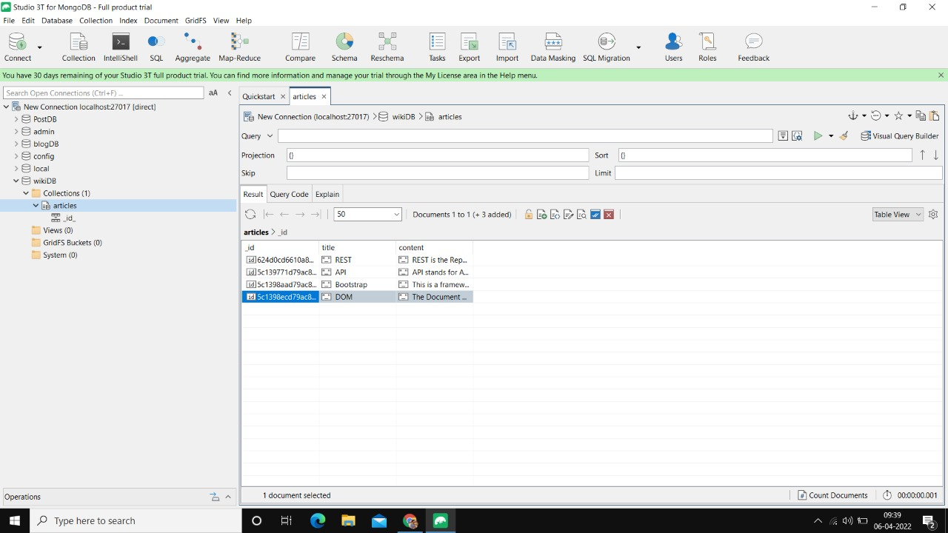

**RESULT**: Hence, the project ‘Wikipedia Lite Version ‘was successfully tested and executed.

THANK YOU